|  |
| --- |
|  |
| Thesis for Master of Engineering |
|  |
| Enhancing the efficiency of animal-alternative *in silico* drug cardiotoxicity prediction through CUDA-based parallel processing |
| December 2024 |
|  |
| Graduate School  Kumoh National Institute of Technology |
|  |
| Department of IT Convergence Engineering |
|  |
| Iga Narendra Pramawijaya |
|  |

|  |
| --- |
| Thesis for Master of Engineering |
|  |
| Enhancing the efficiency of animal-alternative *in silico* drug cardiotoxicity prediction through CUDA-based parallel processing |
| December 2024 |
|  |
| Graduate School  Kumoh National Institute of Technology |
|  |
| Department of IT Convergence Engineering |
|  |
| Iga Narendra Pramawijaya |
|  |

|  |
| --- |
| Enhancing the efficiency of animal-alternative *in silico* drug cardiotoxicity prediction through CUDA-based parallel processing |
|  |
| Supervisor Ki Moo Lim |
|  |
| This Thesis Presented for the Master of Engineering |
| December 2024 |
|  |
| Graduate School  Kumoh National Institute of Technology |
|  |
| Department of IT Convergence Engineering |
|  |
| Iga Narendra Pramawijaya |

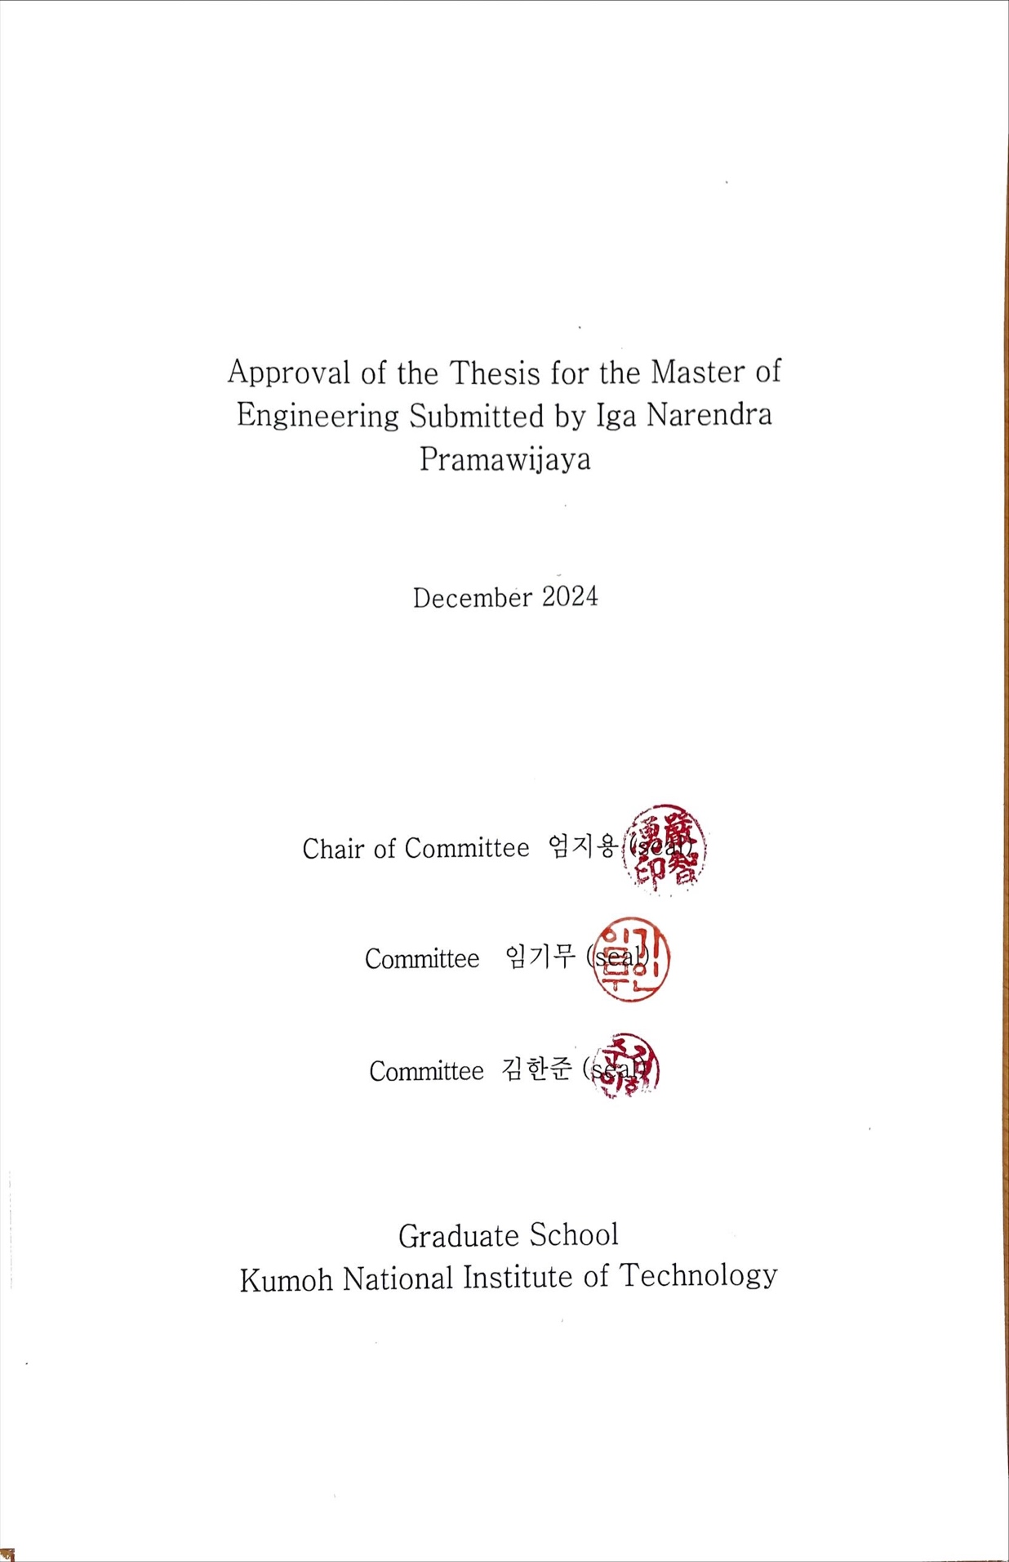

|  |
| --- |
|  |

|  |
| --- |
|  |
| Enhancing the efficiency of animal-alternative *in silico* drug cardiotoxicity prediction through CUDA-based parallel processing |
|  |
| Iga Narendra Pramawijaya |
|  |
| Department of IT Convergence Engineering,  Graduate School  Kumoh National Institute of Technology |
|  |
| Abstract |
|  |

Introduction: This research focuses on enhancing *in silico* cardiotoxicity prediction by utilising GPU-based parallel computing. Traditional CPU-based simulations are computationally expensive, especially for large-scale studies. By leveraging CUDA programming, this research aims to optimise simulation efficiency while maintaining the accuracy of cellular electrophysiological models.

Method: The study employed three well-established cardiac cell models: ORd 2011, ORd 2017, and ToR-ORd. Simulations were conducted using GPU-based implementations of ordinary differential equation (ODE) solvers, with the Rush-Larsen method applied for ORd 2011 and a Forward Euler approach for ORd 2017 and ToR-ORd. The simulations were validated against CPU-based OpenCOR results, with performance evaluated in both drug-free and drug-induced conditions.

Results: GPU simulations demonstrated equivalent accuracy to CPU-based results, effectively replicating action potential dynamics and key biomarkers across all cell models. However, the Forward Euler solver required more computation time compared to the Rush-Larsen method. Computational performance analysis revealed significant efficiency improvements in GPU-based simulations, particularly in handling large-scale datasets.

Conclusion: This research successfully validates GPU-based parallel computing as a reliable and efficient approach for *in silico* cardiotoxicity prediction. The findings support its potential for accelerating drug discovery processes while reducing reliance on animal testing. Future work will focus on expanding model complexity and variabilities to further enhance the system’s applicability

|  |
| --- |
|  |

|  |
| --- |
| CUDA기반 병렬처리를 통한 동물대체 인실리코 약물 심독성 예측 효율성 증대 |
|  |
| Iga Narendra Pramawijaya |
|  |
| 국립금오공과대학교 대학원 IT융복합공학과 |
|  |
| 요 약 |
|  |

소개 : 본 연구는 GPU 기반 병렬 컴퓨팅을 활용하여 *in silico* 심장 독성 예측을 향상시키는 데 초점을 맞추고 있습니다. 기존의 CPU 기반 시뮬레이션은 대규모 연구에서 계산 비용이 높아 비효율적입니다. CUDA 프로그래밍을 활용하여 세포 전기생리학 모델의 정확성을 유지하면서 시뮬레이션 효율성을 최적화하는 것을 목표로 합니다.

방법 : 본 연구에서는 ORd 2011, ORd 2017, ToR-ORd 모델이라는 세 가지 잘 확립된 심장 세포 모델을 사용했습니다. ODE(상미분방정식) 해석기를 GPU 기반으로 구현하였으며, ORd 2011에는 Rush-Larsen 방법을, ORd 2017 및 ToR-ORd에는 Forward Euler 방법을 적용했습니다. 시뮬레이션 결과는 CPU 기반 OpenCOR 결과와 비교하여 검증하였으며, 약물 없는 상태와 약물 유도 상태 모두에서 성능을 평가했습니다.

결과 : GPU 시뮬레이션은 모든 세포 모델에서 CPU 기반 결과와 동일한 정확성을 보였으며, 활동 전위 역학 및 주요 바이오마커를 효과적으로 재현했습니다. Forward Euler 방법은 Rush-Larsen 방법에 비해 계산 시간이 더 오래 걸렸습니다. 계산 성능 분석에서는 특히 대규모 데이터셋 처리에서 GPU 기반 시뮬레이션이 상당한 효율성 개선을 보여주었습니다.

결론 : 이 연구는 GPU 기반 병렬 컴퓨팅이 신뢰할 수 있고 효율적인 인실리코 심장독성 예측 방법임을 성공적으로 입증했습니다. 연구 결과는 약물 개발 과정을 가속화하고 동물 실험 의존도를 줄이는 데 기여할 가능성을 뒷받침합니다. 향후 연구에서는 모델의 복잡성과 변동성을 확장하여 시스템의 적용 가능성을 더욱 향상시키는 데 중점을 둘 것입니다

|  |
| --- |
| Enhancing the efficiency of animal-alternative *in silico* drug cardiotoxicity prediction through CUDA-based parallel processing |
|  |
| Thesis for Master of Engineering |
| December 2024 |
| Iga Narendra Pramawijaya |